WC eServices

Finance Role Instructions

This document will walk you through how to access the reports that are available in the Finance section.

Weekly Warrant Report
Provides the weekly compensation expenditures for each agency. The weekly warrant primarily details the previous Sunday through Saturday pay period and is updated every Thursday.

- Select Weekly Warrant Report from the left nav bar.
- Select the Secretariat, Agency or Department from the Level section (the grey box).
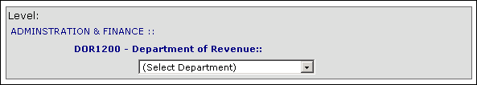
- Click on the Run Weekly Warrant Report button.
- To export the report to Excel click on the Export to Excel button.

Expenditure Detail Report (EDR)
Details all claims related charges to the agency for the current billable month.

- Select Expenditure Detail Report (EDR) from the left nav bar.
- Select the Secretariat, Agency or Department from the Level section (the grey box).
- Click on either the Run Monthly Expenditure Detail Report button or the Run Weekly Expenditure Detail Report button.
- To export the report to Excel click on the Export to Excel button.

Monthly Financial Statement (MFS)
Provides current monthly charges and credits and fiscal year-to-date agency account balance.

- Select Monthly Financial Statement (MFS) from the left nav bar.
- Select the Secretariat, Agency or Department from the Level section (the grey box).
- Click on the Run Monthly Financial Statement button.
- To export the report to Excel click on the Export to Excel button.

