WC eServices

Health and Safety Role

The Health and Safety role will have access to injury and illness information that can be useful for prevention. This document will walk you through how to access the reports that are available in the Health and Safety Role section.

RTW Report
Provides return to work data filed by each agency. This report will have data related to each agency by occupation code along with the number of days lost or modified duty associated with each claim.

- Select RTW Report under report from the left navigation bar.
- Select the Secretariat, Agency or Department from the Level Section (the grey box).

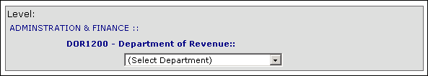

3. The RTW report can be run by calendar year or date range.

- To export the report to Excel click on the Export to Excel button.

Days Away/Summary Reports
Provides a detail report related to the number of days away from work and a summary report on every RTW/Status Change form filed by each agency.
- Select Days Away/Summary Report under report from the left navigation bar.

2. Select the Secretariat, Agency or Department from the Level Section (the grey
box).

- The Run Case with Days Away From Work or Summary Report can be run by calendar year or year range.

- To export the report to Excel click on the Export to Excel button.

