WC eServices

NOI Role Instructions

This NOI role is a subset of the Adjuster role and only has access to submit and view Notice of Injuries. When a user with this role logs into eServices, the following menu will appear in the left navigation bar.



Submit Notice of Injury

- Click on the Notice of Injury link.
- Begin the process of filing a Notice of Injury by filling in the Employee’s SSN, Injury Date, and choosing the Department where the Employee works.

- Click Enter to continue.

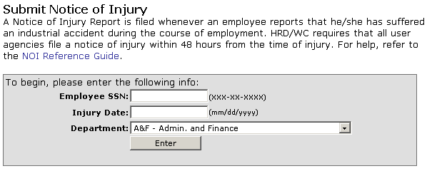

- Once logged in, please refer to the NOI Reference Guide for instructions on how to fill out the remainder of the NOI.

View Submissions
You can view NOI Submissions made by you or by other users in your Department.
- Click on the My Submissions link from the left nav bar.

- To view your submissions, select the My NOI Submissions option.



- Select the All NOI Submissions option to view all NOI submissions in your department.

- You can view the complete NOI by selecting the View link from the list, and view a printable copy of the NOI by clicking on the Print View on the following page.

