WC eServices

Utilization Review Role

This document will walk you through how to access the Utilization Review Determination Letters.

Search Letters

- The UR Letters can be searched by Name, File Number, Date of Injury or Letter Type.
Note: Currently, under “Letter Type” UR Letters can only be accessed/searched by “Historical Letters (prior to August 2004)”

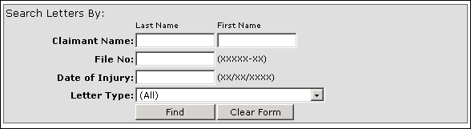

- From the list, select the claimant by clicking on the File No.

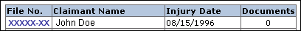

- From the document list, select the letter you wish to view.

- You may need to enable macros when downloading a UR letter.

