WC eServices

Adjuster Role Instructions

This document will walk you through how to access the reports that are available in the Adjuster section.

Claims Information
Provides claimant data profiles.

- Select Claims Information from the left nav bar.
- Search by Claimant Name or File Number.

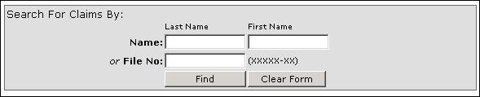

- From the list, click on the File Number of the claim you wish to view. Claims listed in Bold are currently active.

Active Claims Report
Provides a breakdown of the total expenditures paid on each Active claim.
- Select Active Claims Report from the left nav bar.

- Select the Secretariat, Agency or Department from the Level section (the grey box).

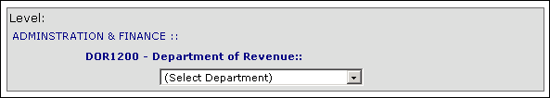

- Click on the Run Active Claims Report button.

- To export the report to Excel click on the Export to Excel button.

180-Day Claims Report
Provides a breakdown of the total expenditures paid on all claims that are less than 180 days old.

- Select 180-Day Claims Report from the left nav bar.
- Select the Secretariat, Agency or Department from the Level section (the grey box).
- Click on the Run 180 Day Report button.
- To export the report to Excel click on the Export to Excel button.

Agency Count of Notice of Injuries
Provides a count of the number of Notice of Injuries filed by each agency.

- Select Agency Count of Notice of Injuries from the left nav bar.
- Select the Secretariat, Agency or Department from the Level section (the grey box).
- The report can be run by Fiscal Year, Date Range or Year Range. Fill out the appropriate information and click on the Run Report button.
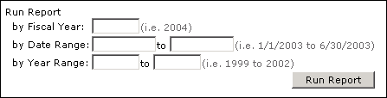
- To export the report to Excel click on the Export to Excel button.

Agency Count of Lost Time Claims
Provides a count of the number of Lost Time Claims filed by each agency.

- Select Agency Count of Lost Time Claims from the left nav bar.
- Select the Secretariat, Agency or Department from the Level section (the grey box).
- The report can by run by Fiscal Year, Date Range or Year Range. Fill out the appropriate information and click on the Run Report button.
- To export the report to Excel click on the Export to Excel button.

